Slide 1: Slavery in the Bible
Good morning, everyone. This morning we are looking at the question of Slavery and whether the Bible condones or endorses slavery. Keep in mind this is just an introduction to a complex topic.
So, does the Bible condone slavery? I’m going to suggest that the Bible describes and regulates an ancient social practice without explicitly condemning it.

To begin, slavery is generally considered a moral evil even though it still exists and affects an estimated 50 million people worldwide. Although chattel (ownership, possession) slavery is illegal globally, modern slavery persists as an umbrella term for forced labor, human trafficking, debt bondage, and forced marriage. https://www.antislavery.org/slavery-today/modern-slavery/
According to the latest Global Estimates of Modern Slavery (2022) from Walk Free, the International Labor Organization and the International Organization for Migration:
- 49.6 million people live in modern slavery – in forced labor and forced marriage
- Roughly a quarter of all victims of modern slavery are children
- 22 million people are in forced marriages. Two out of five of these people were children
- Of the 27.6 million people trapped in forced labor, 17.3 million are in forced labour exploitation in the private economy, 6.3 million are in commercial sexual exploitation, and nearly 4 million are in forced labour imposed by state authorities
- The COVID-19 pandemic has exacerbated the conditions that lead to modern slavery
- Migrant workers are particularly vulnerable to forced labour.
Source: Global Estimates of Modern Slavery: Forced Labor and Forced Marriage, Geneva, September 2022

Slide 2: Why does this question matter?
The objection: "The Bible permits and even endorses slavery — how can a good God allow this?"
This objection may come from:
- Skeptics and atheist critics
- Students encountering Scripture for the first time
- Believers shaken by historical discoveries
- Former Christians deconstructing their faith

Our Approach: This is a difficult question. So we will ask some questions of our own:
- What did 'slavery' actually mean in the ancient world?
- How does ANE law compare to biblical law?
- What trajectory does the Bible set in motion?
- How does the NT transform the institution?

Slide 3: First: We Define our Terms
OT - Hebrew: 'Eved - Has a wide range of meanings based on the context. Broadly, the word means 'servant' or 'worker.' Used for paid employees, indentured servants, debt workers, slaves and high-ranking royal officials. Context always determines meaning.
NT – Greek doulos - In the Greco-Roman context, could mean slave, but also 'bond-servant.' Paul calls himself a doulos of Christ — a term of devotion. Context governs meaning.
Modern term ‘Slavery’ – When we think of slavery, we often refer to the transatlantic slave trade (16th–19th c.), which was race-based, chattel slavery — permanent, hereditary, and dehumanizing. This is NOT what the biblical texts describe.

Slide 4: The Ancient Near Eastern World
How did Israel’s laws compare to those of surrounding cultures?
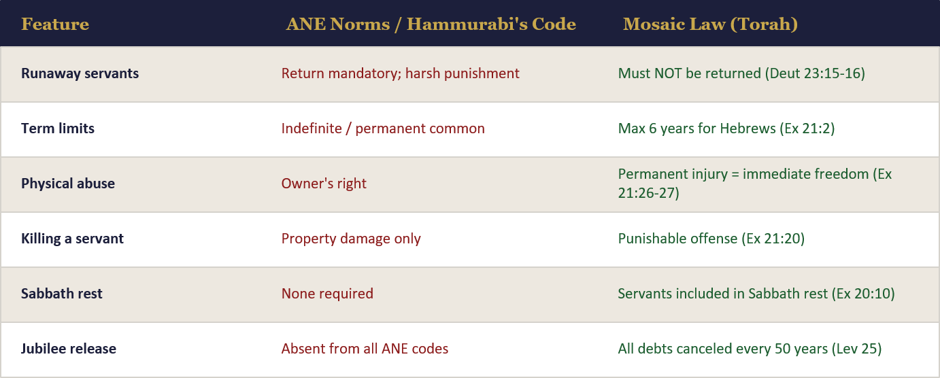

Slide 5: Types of Servitude in the Old Testament
1: Debt Servitude - Voluntary entry to repay debts. Limited to 6 years (Ex 21:2). Servant retained rights and personhood. A social safety-net mechanism, not ownership.
2. War Captives - A complex and difficult category. In context, often an alternative to execution — the ANE norm. Rights still applied. Most challenging for modern readers.
3. Voluntary Covenant relationship - Could choose permanent status out of love for family (Ex 21:5-6). An ear-piercing ceremony marked the covenant. Entirely voluntary — social security of the ancient world.
4. Foreign Servants (Gentiles) – Lev. 25:44-46. Could be of longer, even perpetual, duration. Sabbath rest is required; injury laws apply. Not racially defined; could join the covenant community.

Slide 6: Examples of Some of the Hard Texts
Passages critics most often cite – context matters
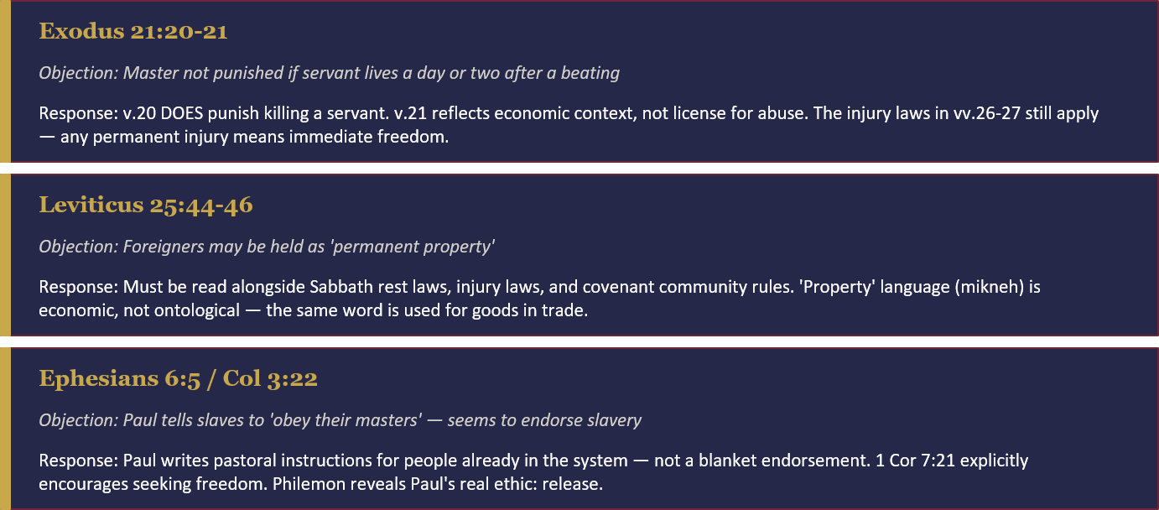

Slide 7: Progressive Change
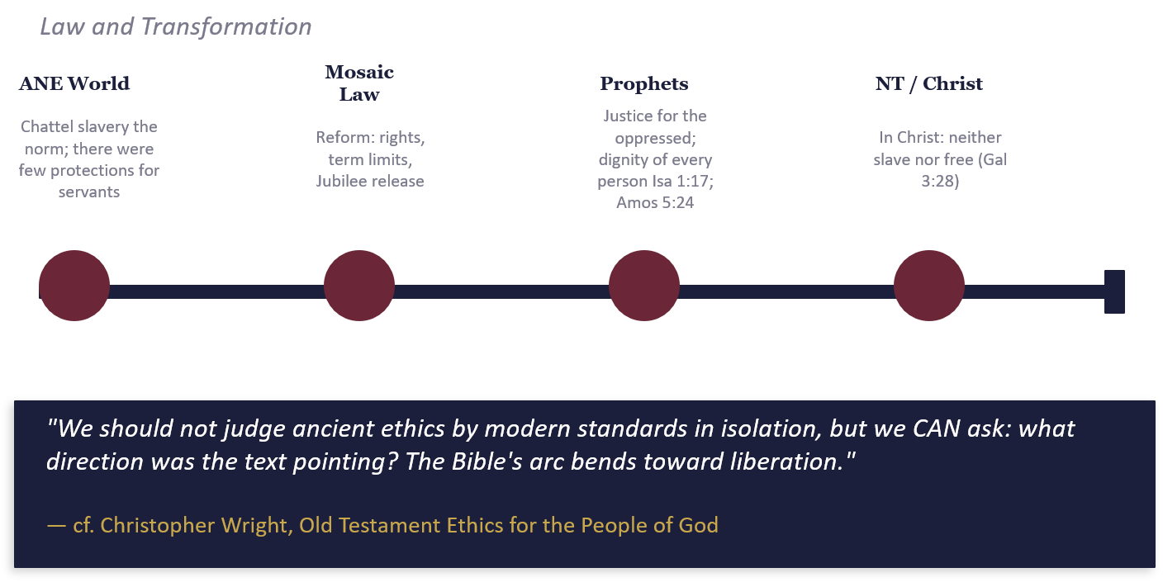

Slide 8: The New Testament
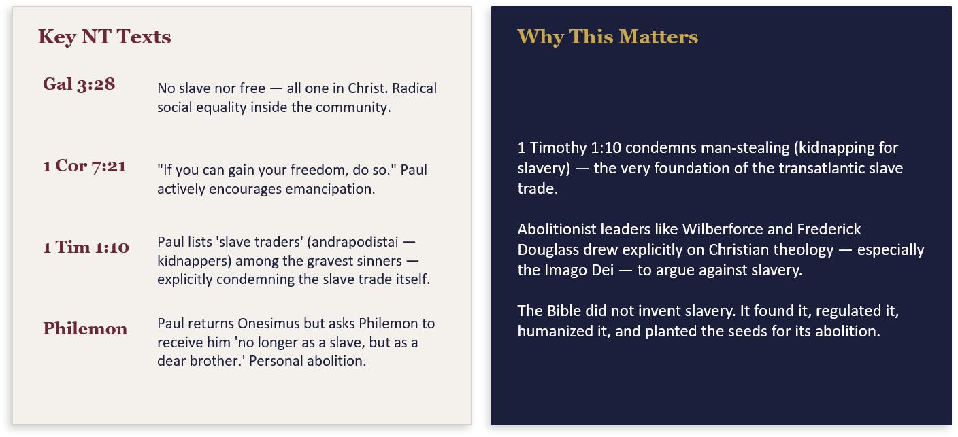

Slide 9: Answering Common Objections
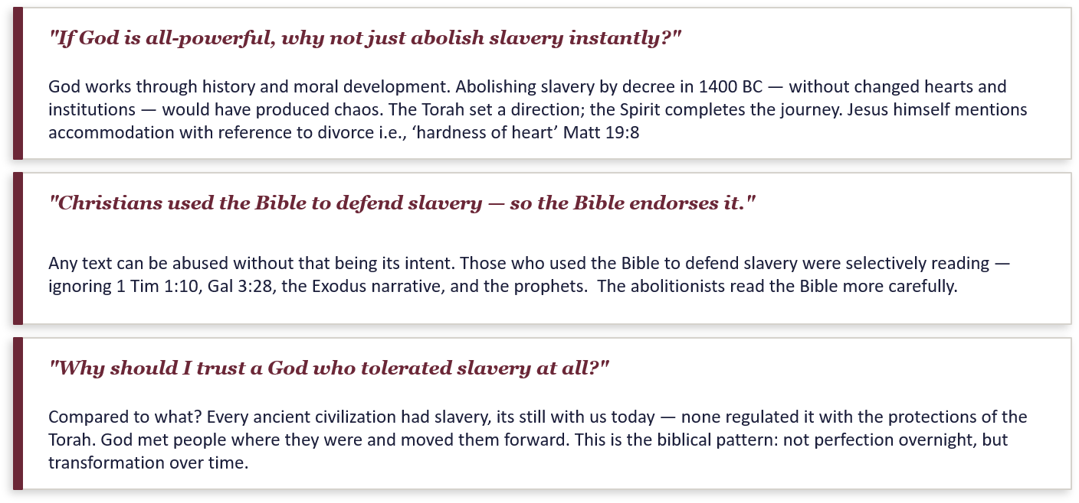

Slide 10: Summary & Key Points

Slide 11: Discussion Handout

Slide 12: Resources
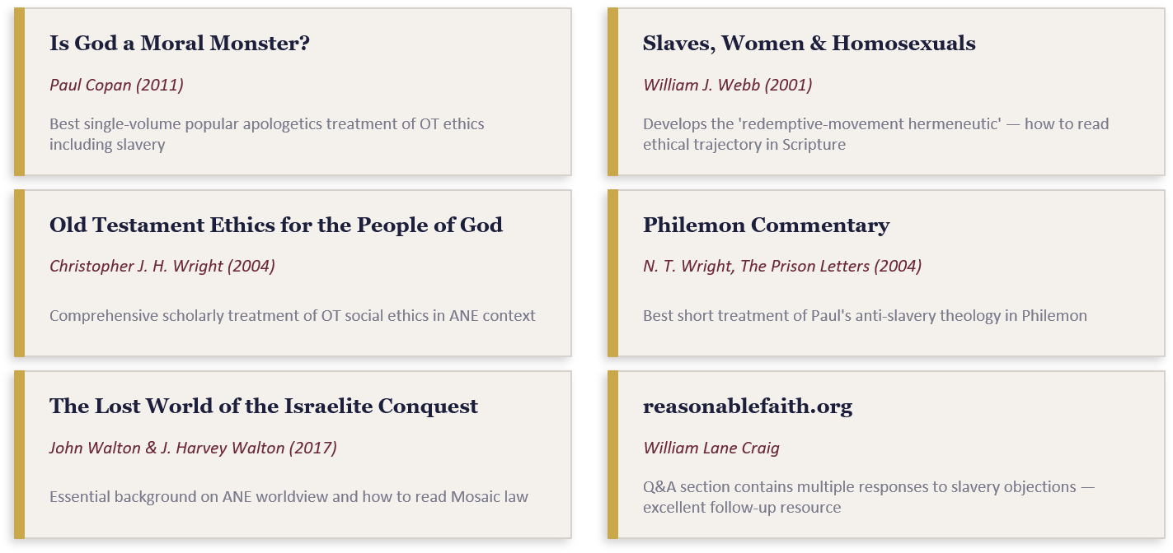

Hebrew Word Study - https://www.chaimbentorah.com/2020/03/hebrew-word-study-indentured-servants/

